Collaborative TODO Manager Application (CTMA) Design Document
Design, Implementation, and Verification of the CLI Prototype

Full Name(s) of Author(s)
Institution
Course
Instructor
Date of Submission

1. Introduction and Architectural Overview

1.1 Purpose and Scope
This document includes the engineering description and architectural design of the first prototype of the Command-Line Interface (CLI) of the Collaborative TODO Manager Application (CTMA), written in Python. Specifically, it addresses the fundamental CRUD (Create, Read, Update, Delete) functionality created during Milestone 2 and provides the framework on which the subsequent Graphical User Interface (GUI) and collaboration among multiple users features are to be built.

1.2 Architectural Pattern: Layered CLI (MVC-Style)
The existing architecture follows a Layered Design Pattern, with strict separation of presentation, business logic and data modeling, to provide high modularity and testability.
Table 1 Layered Architecture and Component Responsibilities
Layer | Component/File | Responsibility
Presentation (CLI) | main.py, user_flow.py (Menus) | Handles program entry, displays the main menu, validates user navigation choices, and manages program exit/persistence calls.
Business/Application Logic | handler.py / user_flow.py (Functional Methods) | Manages the application state (todoList), orchestrates task manipulation, implements search/filtering, and enforces business rules.
Data/Model Logic | todo.py (the ToDo class) | Defines the data structure and provides object-specific mutation methods. This layer is central to the Milestone 2 "No-AI Zone."
Configuration/Testing | conftext.py, constants.py, test_* files | Stores static configurations (Priority Map) and houses all unit and integration testing logic (Pytest).
Persistence | handler.py (loadSave, saveData) | Manages robust file I/O using JSON serialization to persist the in-memory todoList state.
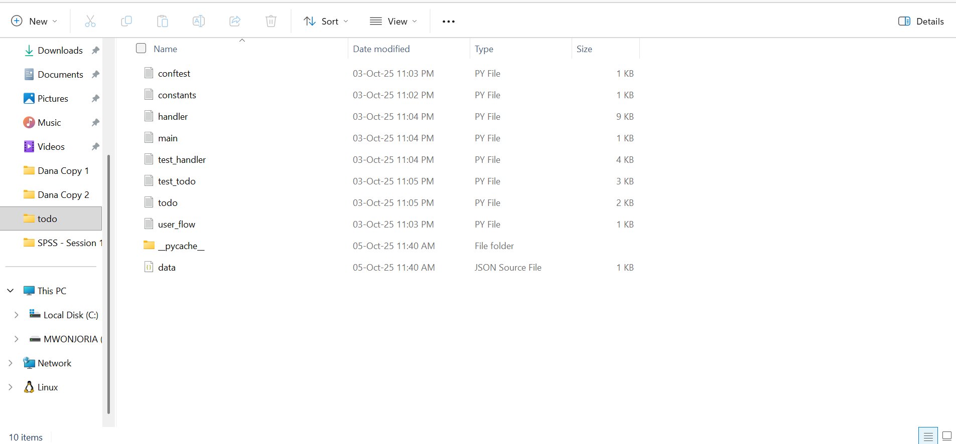
Figure 1 A screenshot of the file explorer showing the project's folder structure, verifying the existence of all Python files and data.json

2. Data Model and Core Logic (No-AI Zone)

2.1 Core Data Model: ToDo Class Specification (todo.py)
The ToDo class encapsulates all task data and internal mutation methods, ensuring data integrity is controlled at the object level.
Table 2 Class Data Model Specification
Attribute | Data Type | Description
label | String | Task title/name. Must be non-empty upon creation.
dueDate | String | Task deadline (currently accepts unvalidated string input).
priority | String | Task priority (Mapped from keys in PRIORITYDICT in conftext.py).
category | String | Used for organizational filtering.
idNum | Integer | 1-indexed identifier used for user selection in the CLI. Automatically re-indexed upon task deletion.
complete | Boolean | Internal status tracking (True = Complete, False = Ongoing).
status | String | Display status ("Ongoing" or "Complete").

2.2 Data Persistence and I/O (handler.py)
- Mechanism: The tasks are kept in the memory in the form of handler.todoList. The list is serialize to dictionary format and dumped to data.json.
- As shown, loading (loadSave) reads the JSON dictionary and recreates the list of ToDo objects, restoring the state of the application.
- Error Handling: try... except FileNotFoundError: This provides a clean boot to new users, loading a blank data.json so that all can begin with empty data.json... Input validation in the handlers acts as a safeguard against catastrophic failure.

2.3 Core CRUD Implementation Details (handler.py)
The functions below represent the primary implementation of the No-AI Zone business logic:
Table 3 Core CRUD Implementation Details and No-AI Zone Logic
Operation | Method(s) | Key Implementation Details
Create (C) | createTodo | Validates label is non-empty. Maps user input (1-4) to string priority levels (PRIORITYDICT).
Read (R) | viewTodos, viewTodosInfoed, search | viewTodos (simple list) supports task selection; viewTodosInfoed provides full task detail (ToDo.__str__). search performs a case-insensitive match on Label, Category, and Priority.
Update (U) | editTodo, changeCompletion | Uses a declarative dictionary of lambda functions to map CLI menu choices to specific ToDo object mutation calls.
Delete (D) | deleteTodo | Removes the task via todoList.pop(selection - 1). Crucially, it re-indexes all remaining tasks by iterating and resetting the idNum attribute to maintain sequence integrity (NFR-1.1).
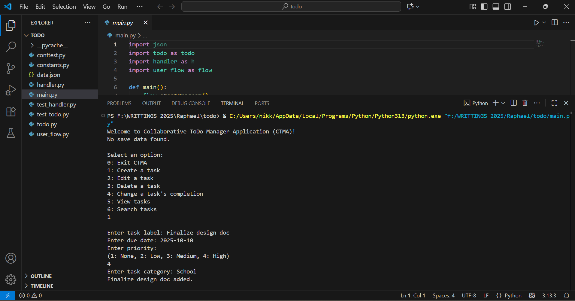
Figure 2 A screenshot of the console showing the output of View Tasks (Detailed) to demonstrate the ToDo.__str__ formatting

3. Testing and Quality Assurance

3.1 Testing Strategy
Strict testing is enforced on the Pytest framework in two levels: unit and integration testing.

Unit Tests (test_todo.py)
These tests focus exclusively on the Data Model Layer (todo.py), confirming object reliability:
- Validation of object initialization and data integrity.
- Verification of the __str__ and printLabel output formats.
- Confirmation of correct data mutation via editLabel, editPriority, and toggleComplete.

Integration/Handler Tests (test_handler.py)
These tests focus on the Application Logic Layer and system flow:
- Persistence: test_loadsave and test_savedata check the proper reading/writing of data to/from the mocked data.json.
- Data integrity: test_delete_todo has an explicit assertion that the re-indexing logic is followed correctly when a task is deleted.
- Input Handling: Tests are used to check that the application can process invalid numeric data (test_invalid_selection) and that a required field exists (test_invalid_create).
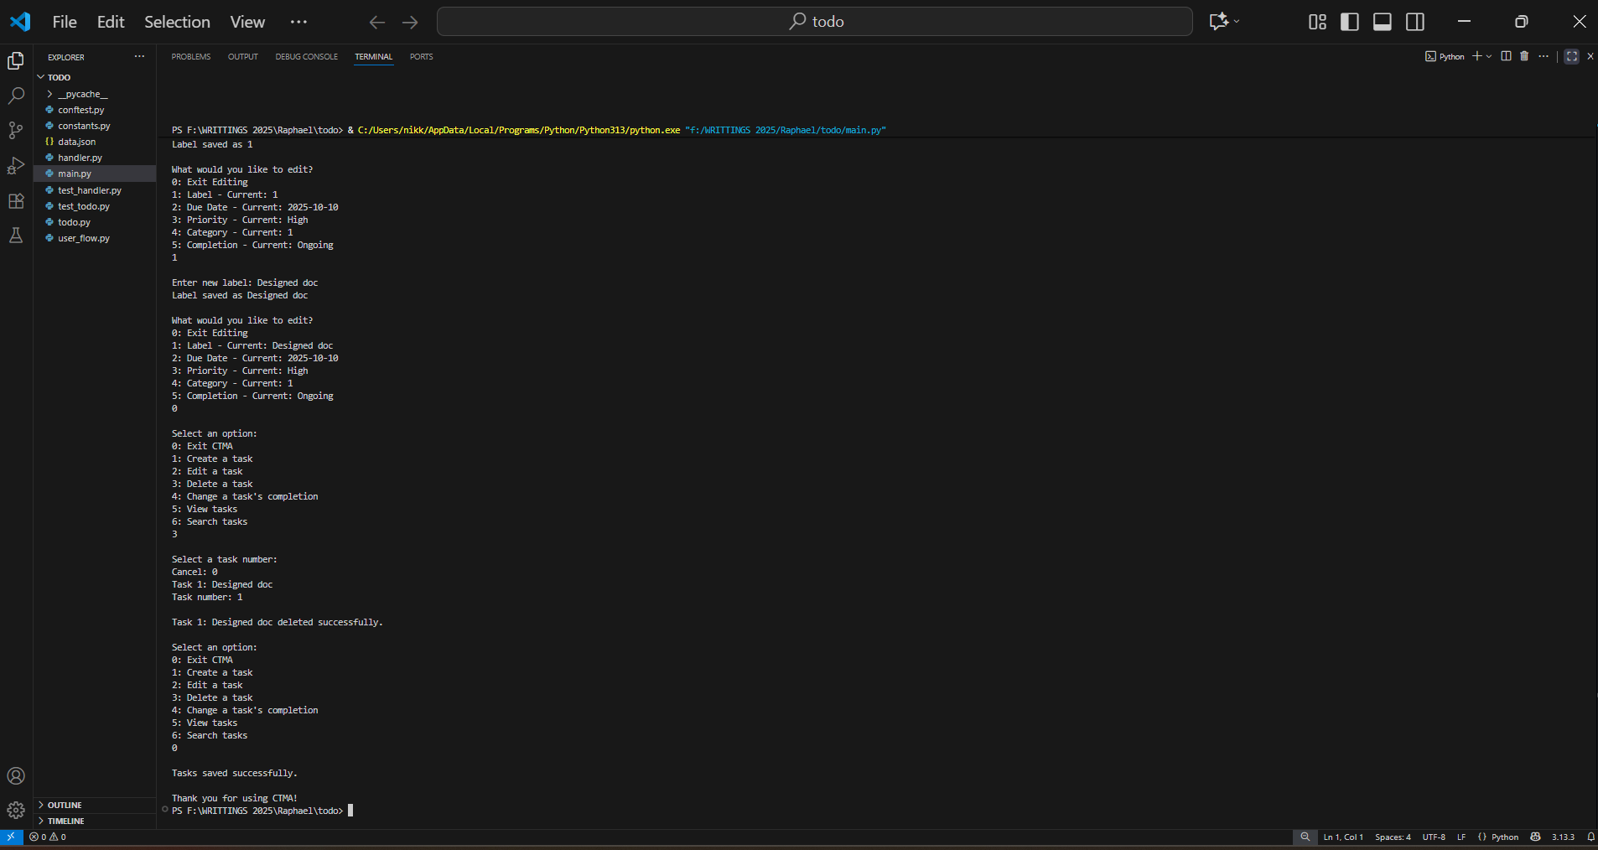
Figure 3 A screenshot of the console showing Pytest running, verifying all tests (test_handler.py and test_todo.py) have successfully passed

